LYMPHOID ORGANS
The organs associated with immune system are called as lymphoid organs. They are diverse in origin and carry our various functions. They may be distinguished into two types based on their function. 1) Primary Lymphoid organs and
2) Secondary Lymphoid organs
Primary lymphoid organs are the sites where maturation of lymphocytes takes place. The lymphocytes become competent and then migrate to secondary lymphoid organs.
Eg: Thymus and Bonemarrow.
Secondary Lymphoid organs have the competent lymphocytes and they are concerned with interacting with Ag. Once the competent cells are exposed to Antigenic stimulus, they become functional, by producing antibodies or by producing sensitized cells.
Eg: Lymph nodes, Spleen, MALT, GALT.

Primary Lymphoid organs:
These are the sites for maturation of the immature lymphocytes produced in bone marrow. Upon maturation they become competent to mount immune response. The T-cell mature in thymus while B-cells are produced and they mature in the same site, bone marrow.

Thymus: It is the site for development and maturation of T-cells.
It is a bilobed organ surrounded by capsule and is divided into lobules by trabeculae.
Each lobule has two compartments, the outer cortex and inner medulla.
Cortex is packed with immature T-cells while medulla if populated with mature thymocytes.
Both cortex and medulla both are made up of 3d stromal cell network composed of epithelial cells, dendritic cells and macrophages which contribute to growth and maturation of thymocytes.
Some epithelial cells called nurse cells surround around 50 thymocytes and nourish them.
T-cells develop receptors and are trained by the epithelial cells and dendritic cells not to respond to self Ag’s and to accept specific Ag in association with MHC molecules.
The cells which are self reactive and those which do not engage any of the MHC are eliminated by apoptosis.
Functions of thymus: 1) Production of T-cells
2) Bring about cell mediated immunity.
Play important role in graft rejection.
Thymectomy: Removal of thymus is called thymectomy.
Neonatal thymectomy – removal of thymus immediately after birth. This causes impairment of cell mediated immunity. Grafts are not rejected in this situation and the thymectimized mice develop immunodeficiency.

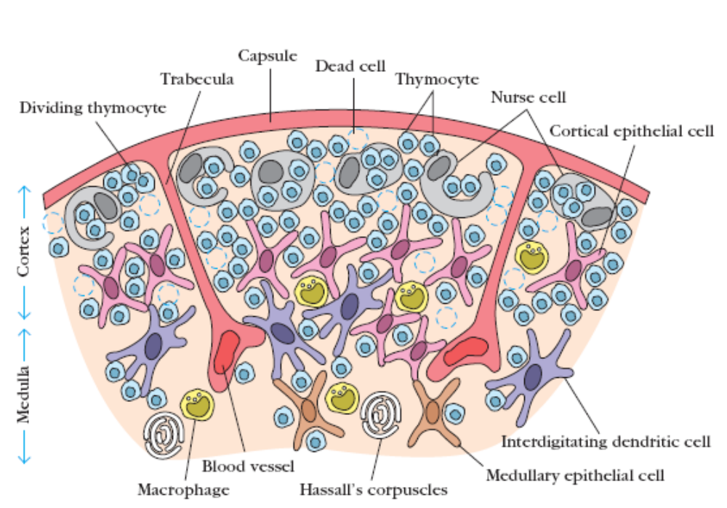
Bursa of Fabricius:
It is a primary lymphoid organ found in birds. It is a sac like lympho-epithelial structure that is formed from the dorsal diverticulum in birds. It was first described by Fabricius (1621). It originates from the hind gut epithelium of the chicken embryo. By 4th month of age it reaches maximum size of 3cm in diameter and then starts degenerating.
It is the primary site for B-cell maturation in birds.
Cross section of bursa shows a similar structure as that of thymus.
It has lobes called follicles and each follicle has an outer cortex and inner medulla.
Bursa has 3 types of cells- the B-lymphocytes, Macrophages and Plasma cells.
The lymphocytes of bursa are called bursa cells. These after maturation migrate to the B-dependent secondary lymphoid organs like the spleen and lymph nodes.
If B-cells get encountered with Ag they produce plasma cells that secrete antibodies.
Like thymic selection B-cells having self reactive antibodies are eliminated by apoptosis.
Therefore Bursa contributes to Humoral immunity.
Bursectomy: Removal of bursa is called Bursectomy.
Neonatal bursectomy effects humoral immunity. It has no effect on cell mediated immunity.
Bone marrow: It is the soft tissue present in the bones and is the site for B-cell prigin and development in mice and human. In mammals it forms the largest tissue weighing 3Kg in an average adult.
Marrow may be divided into 2 regions, 1) Vascular and adipose region
2) Haemopoietic region.
Vascular region supplies nutrients and removes wastes from the actively dividing cells. It constitutes half the weight of the bone marrow.
Haemopoietic region constitutes the red marrow which has the totipotent stem cells. Also called the haemopoietic stem cells, they are involved in the development of all blood cells which include B-cells, Precursors of T-cells, macrophages, erythrocytes, platelets, granulocytes etc.
The B-cells precursors are exposed to all the self antigens and the self reactive cells are eliminated by apoptosis.
In adults bone marrow is yellow in color due to fat deposition.
In fetal stages, liver is involved haemopoietic in this activity , followed by spleen. While in cattle and sheep fetal liver does the role. Later Payers patches of the intestinal wall assume the role during gestation period. They contain >10¹⁰ B-cells.
Functions: Haemopoiesis of all the blood cells.
Synthesis of lymphoid progenitors out of which some form B-cells, while some form the T-cells.
It is also involved in the formation of Antibodies. This is due to accumulation of many plasma cells during a secondary immune response. Hence it is called as a primary as well as a secondary lymphoid organ.

Lymphatic system: When blood flows under high pressure in the fine capillaries, plasma the fluid component seeps out. Much of the plasma, called the Interstitial fluid returns back to blood via capillary membranes which the remainder is called the Lymph.
This lymph is present in the spaces of the connective tissue, and flows into a network of tiny open lymphatic capillaries and then into a series of larger collecting vessels called Lymphatic vessels. The largest vessel is thoracic duct, which empties its contents into the left subclavian vein near heart. In this way lymphatic system captures the lost fluids and returns them back to blood.
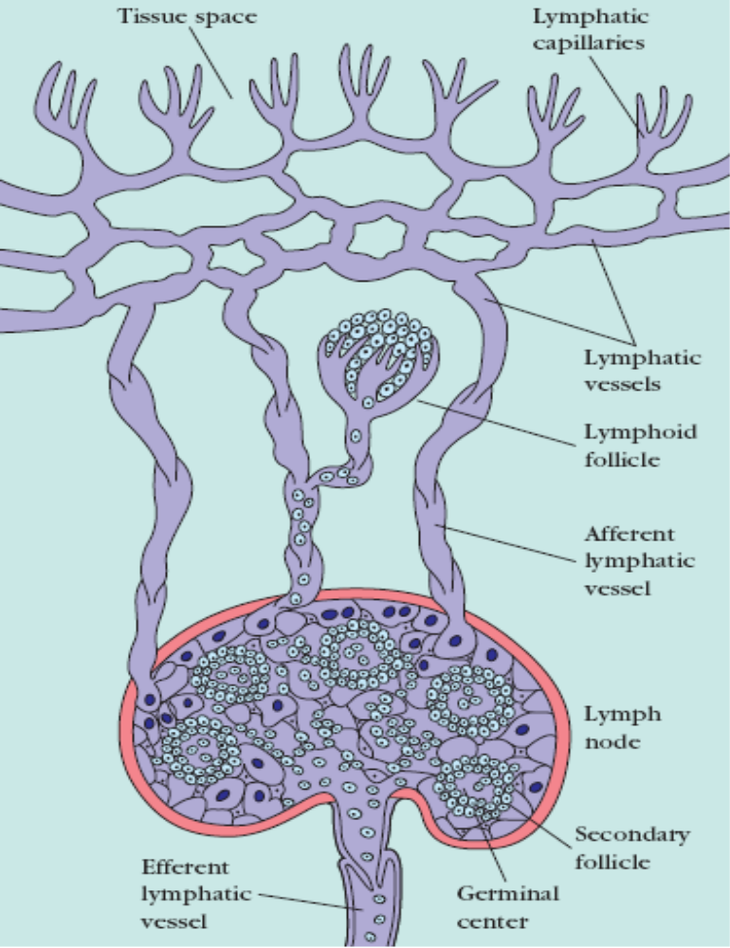
Movement of lymph in the lymphatic vessels is made unidirectional due to the presence of walls and the movement is due to the sqeezing action of body’s muscles during movement. Any foreign Ag’s entering tissues is picked up by the lymphatic system. This system is organized into tissue called lymph nodes which trap the Ag. As the vessels reach the tissue the lymphocyte count is also increased.
These get activated and nullify the Antigen.
Secondary Lymphoid organs: There are various types of lymphoid tissues based on organization. Spleen, lymph nodes, MALT or GALT are supposed to be more organized. Others are organized into aggregates of lymphoid as well as non-lymphoid cells surrounded by a network of draining lymphatic capillaries. Until it is activated, it is called primary follicle and it consists of follicular dendritic cells and resting B-cells.
Following Antigenic stimulus the primary follicle becomes a Secondary follicle. A secondary follicle has a ring of concentrically packed B lymphocytes surrounding a germinal centre. The germinal centre has at its middle proliferating B lymphocytes along with an area which consists non-dividing B-cells, some T cells interspersed by Macrophages and follicular dendritic cells.

Most of the Ag activated B-cells divide and differentiate into Ab producing plasma cells in the follicles. But very few reach the germinal centre and undergo cell division. The genes that encode for an Ab mutate. During this process the cells undergo a process of selection. Those B-cells which produce Ab’s that bind strongly to Ag alone survive, while others are eliminated. After rigorous selection, they differentiate into plasma cells and memory cells. The plasma cells release Ab’s.

Lymphnodes: These are bean shaped structures which eliminate Ag’s that enter lymph. They are encapsulated and contain a network of lymphocytes, macrophages and dendritic cells. They are clustered at the junctions of lymphatic vessels.
Morphologically lymphnode can be dicided into 3 concentric regions.
1) Cortex- has mostly B-cells, some T-cells, Macrophages and follicular dendritic cells.
2) Paracortex- Has mostly T-cells and Interdigitating dendritic cells.
3) Medulla- It is sparsely populated with lymphoid lineage cells, has mostly plasma cells.
After Antigenic challenge in cortex, the primary follicle enlarges into secondary follicle containing germinal centre. The plasma cells from the germinal centre migrate into medulla.
If the antigen is trapped by interdigitating dendritic cells of paracortex, it is presented to T_{H} cells by the Class II MHC molecules. Once activated T_{H} cells and B-cells form small foci at the edge of paracortex. These foci reach maximum size in 4-6 days and containing plasma cells secreting IgM and IgG.
Within 7days of Antigenic challenge, few T_{H}-cells and B-cells migrate to the primary follicles in cortex, interact with follicular dendritic cells. This interaction leads to formation of secondary follicles with germinal centre. Plasma cells form these centres migrate to medulla and then to bone marrow.
Therefore the lymph leaving nodes via efferent lymphatic vessel is enriched in lymphocytes ( by 50 fold) and Ab’s, when compared to Efferent lymph. This increase may be due to proliferation of lymphocytes as well as their migration from the post capillary venule by diapedesis.
Spleen: It plays major role in eliminating blood borne antigens. It is large, ovoid and situated in left abdominal cavity. It is not supplied with lymphatic vessels, instead has splenic vein and splenic artery.
Spleen has two regions: red pulp and the white pulp which are separated by a marginal zone.
Red pulp consists of a network of sinusoids which are populated with macrophages and many erythrocytes with few lymphocytes. Defective and worn out RBC are eliminated by this hence it is called the Grave yard of RBC. Macrophages engulf the RBC and Iron contained in the Haemogobin is reutilized.
White pulp consists of branches of splenic artery surrounded by T-cells and this is called the Periarteriolar lymphatic sheeth(PALS). Primary follicles are found in PALS and these are rich in B-cells.
Marginal zone is located peripheral to PALS and is populated with lymphocytes and macrophages.
The blood borne antigens are trapped by the interdigitating dendritic cells which carry it to the PALS.
Initial activation of T and B cells takes place in PALS. First the Ag is presented by Interdigitating dendritic cells to T-cells which then activate B-cells.
These activated cells migrate to primary follicles which enlarge to form the Secondary follicles containing a germinal centre. The germinal centre has actively dividing B-cells and plasma cell which secrete antibodies that nullify antigen.
Function of spleen: Prevents bacteremia.
Splenectomy: It is removal of spleen.
It increases infections by Staphylococcus pneumonia, Neisseria meningitides and Haemophilus influenza.

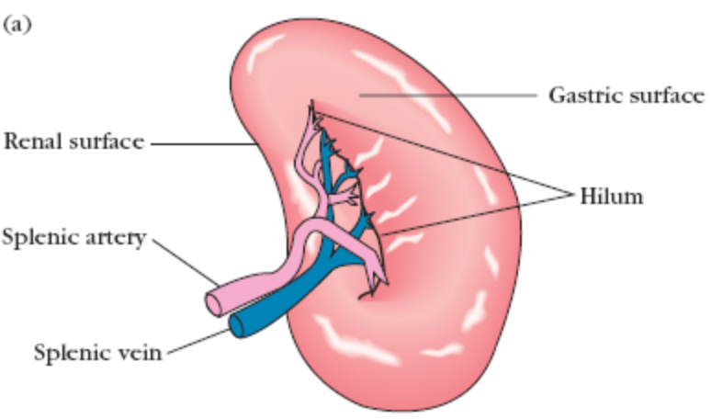
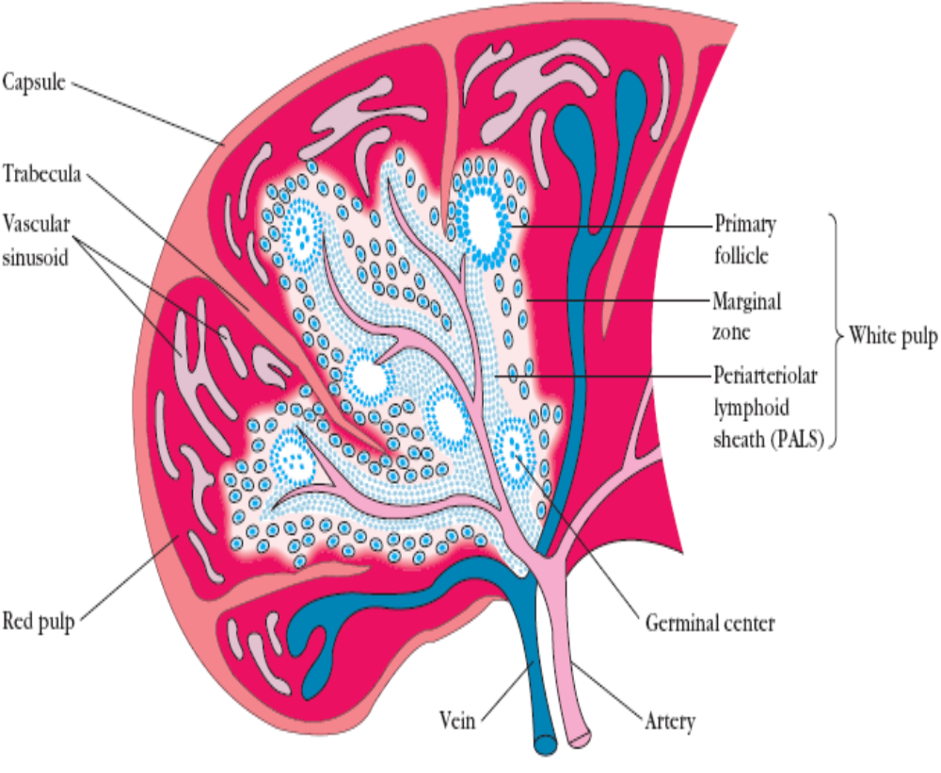

Mucosal associated lymphoid tissue:
The mucous membrane linings of digestive, respiratory and urinogenital tracts when combined form MALT. It combindly has a surface area of 400m² (basket ball court).
Structurally the tissues range from barely organized clusters of lymphoid cells in the lamina propria of intestinal villa to well organized structures such as Payer’s patches, tonsils, appendix etc.
Functionally MALT has the largest population of plasma cells.

Tonsils: These are found in 3 locations
a) Lingual- Found at the base of the tongue
b) Palatine- found at the side of the back of mouth.
c) Pharyngeal (Adenoids)- Found on the roof of nasopharynx.

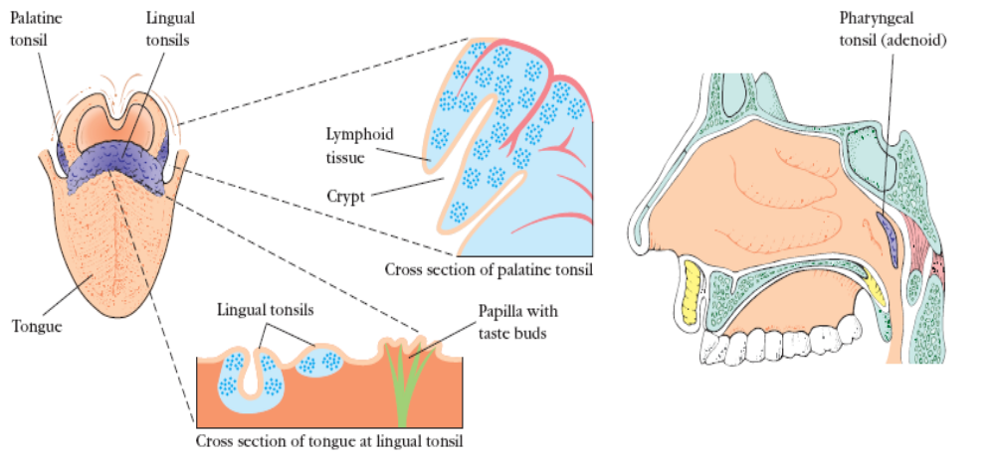

They contain network of reticular cells and fibers interspersed with lymphocytes, macrophages, granulocytes and mast cells.
B-cells are organized into follicles and germinal centres, which are surrounded by regions showing Tcell activity.Tonsils defend against Ag’s entering through nasal and oral routes.
Mucosal lining of gastrointestinal tract:
It includes the above as well as the gastrointestinal tract. Combats Ag that has entered gut and secretes Ab’s. Lymphoid cells are found in various regions in this tissue.
a) Outer mucosal epithelial layer has intra epithelial lymphocytes (IEL’s). These are T-cells with unusual receptors and exhibit limited diversity to Ag’s.
b) Lamina propria contains large number of B-cells, plasma cells and activated T_{H} cells and Macrophages in loose clusters. A healthy child has around 15000 lymphoid follicles in the lamina propria.
c) Submucosal layer: Contains Payer patches, which have 30 to 40 lymphoid follicles. These develop into secondary follicles upon antigenic challenge.
The epithelial cells of mucous membrane are important in promoting Immune response. This layer transports Ag to lower layers and this is by M-cells.

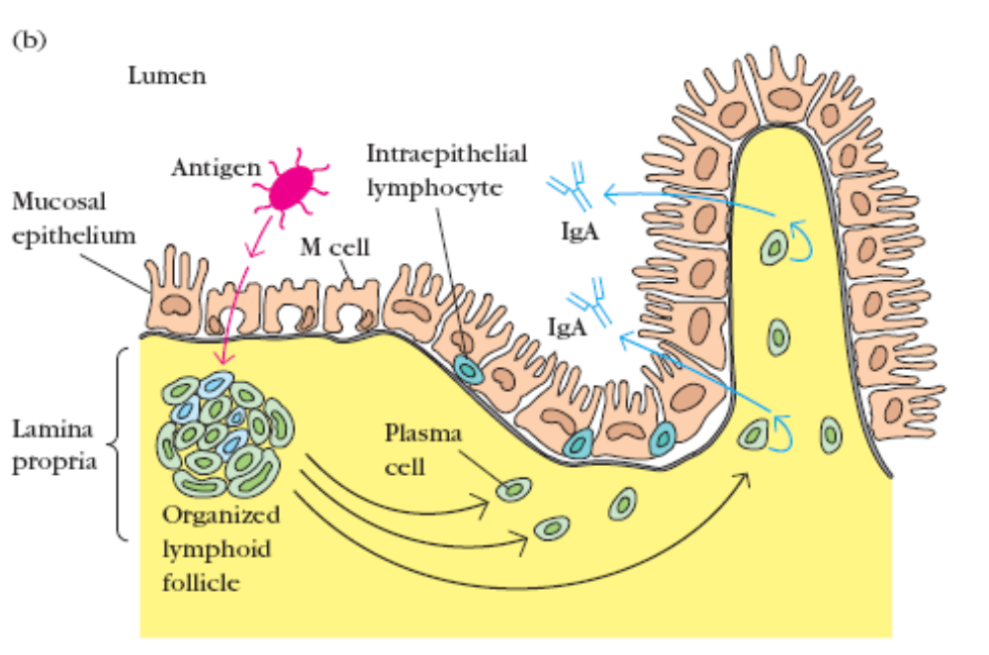
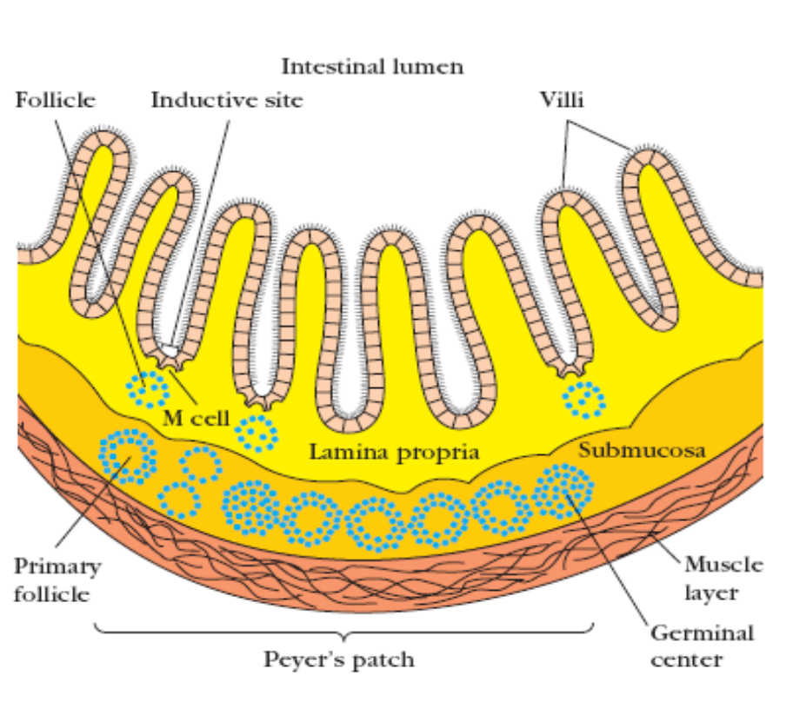

M-cells: These are flattened epithelial cells lacking microvilli.
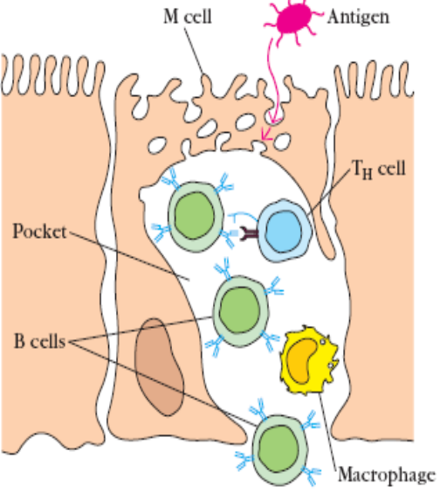
They have deep invagination or pocket in the
Basolateral plasma membrane. The pocket has B,T cells
and macrophages.
Antigens are endocytosed by M-cells and the vesicles
formed fuse with pocket membrane, delivering Ag’s
to the cells in the pockets.
M-cells are usually located in the so-called inductive
sites which are small regions having organized
lymphoid follicles below them.
Antigen activated B and T cells migrate to lymphoid follicles. Plasma cells so formed secrete IgA which is given out into the lumen as secretory IgA to interact with Ag. Though M-cells are sites for Ag capture, some pathogens like Salmonella apa, Vibrio cholerae and Polio virus reuse these cells as invasive routes.

Cutaneous Associated Lymphoid tissue (CALT):
The innate immunity constituted by the stratum corneum of skin has some epithelial cells called Keratinocytes having the capacity to secrete several cytokines constituted by CALT. These cytokines induce inflammatory reponses. Some keratinocytes function as APC’s.
Epithelial cell matrix also has Langerhan cells, some dendritic cells which are phagocytic.
Langerhan cells migrate from epidermis to lymphnodes where they differentiate into interdigitating dendritic cells. These cells have Class II MHC molecules which activate naïve T_{H} cells. Epidermis also has intra epidermal lymphocytes which have mostly CD8 T cells.

Important questions:
- Write a detailed account on Thymus? Explain its role in cell mediated immunity. 14
- Explain in detail the structure of spleen with a neat labeled diagram. What is splenectomy and what are the consequences of splenectomy. 14
- Write a brief note on MALT. 7
- Explain the role of Bursa in B-cell development. 7
- Explain the role of Bone marrow in T and B –cells development. 10

